When a user connects to a DataSource using Power BI desktop the credentials used are stored in Power BI desktop. These credentials might require to be removed at some point. This document provides a guide to how to remove credentials from a user's machine in Power BI desktop.

1. Open Power BI Desktop
2. In the menu bar ensure ‘Home’ is selected, then click on the button labelled ‘Transform data’ this will open the Power Query Editor window.

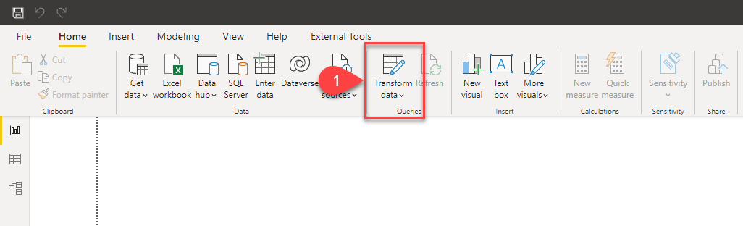

1. Once the Power Query Editor window has opened then click on the button labeled ‘Data source settings’

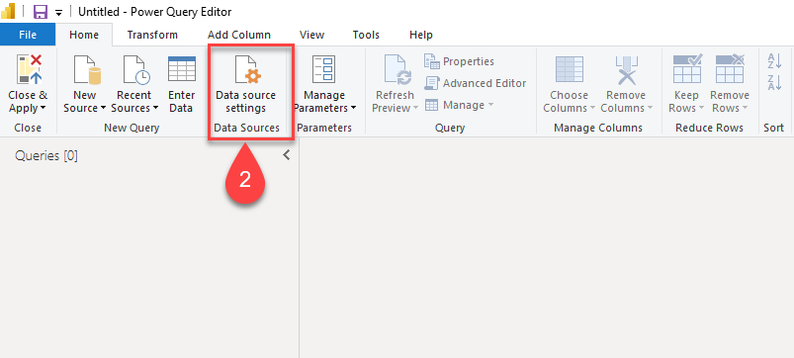

1. The Data source settings window will open, this will show all the stored credentials for the person which is using Power BI Desktop.

At this point, there are two options, either select a data source (no they are not always given easy to recognize names). Or if click on the pull down list, you can click on the 2nd option to ‘Clear All Permissions’. Note that this second option will clear permission for all the data sources.

